create database Bank_Database1BM23CS152;

show databases;

use Bank_Database1BM23CS152;

create table Branch(Name varchar(20),City varchar(20), Assets varchar(20), primary key(Name));

create table BankAccount(accno varchar(20),Name varchar(20), Balance varchar(20),

primary key(accno,Name),foreign key(Name) references Branch(Name)) ;

create table Customer(name varchar(20),Street varchar(20), City varchar(20),primary key(name));

create table Depositer(name varchar(20),accno varchar(20),

primary key(name,accno), foreign key(name) references Customer(name),foreign key(accno) references

BankAccount(accno));

create table Loan(loan_no varchar(20),Name varchar(20), Amount varchar(20),

primary key(Name), foreign key(Name) references Branch(Name));

insert into Branch values("SBI_Chamrajpet", "Bangalore", 50000);

insert into Branch values("SBI_ResidencyRoad", "Bangalore", 10000);

insert into Branch values("SBI_ShivajiRoad", "Bombay", 20000);

insert into Branch values("SBI_ParlimentRoad", "Delhi", 10000);

insert into Branch values("SBI_Jantarmantar", "Delhi", 20000);

insert into BankAccount values(1, "SBI_Chamrajpet",2000 );

insert into BankAccount values(2, "SBI_ResidencyRoad", 5000);

insert into BankAccount values(3, "SBI_ShivajiRoad", 6000);

insert into BankAccount values(4, "SBI_ParlimentRoad", 9000);

insert into BankAccount values(5, "SBI_Jantarmantar", 8000);

insert into BankAccount values(6, "SBI_ShivajiRoad", 8000);

insert into BankAccount values(8, "SBI_ResidencyRoad", 8000);

insert into BankAccount values(9, "SBI_ParlimentRoad", 8000);

insert into BankAccount values(10, "SBI_ResidencyRoad", 8000);

insert into BankAccount values(11, "SBI_Jantarmantar", 8000);

insert into Customer values("Avinash", "Bull temple road","Bangalore" );

insert into Customer values("Dinesh", "Bannerghatta Road","Bangalore" );

insert into Customer values("Mohan", "NationalCollegeRoad","Bangalore" );

insert into Customer values("Nikhil", "Akbar Road","Delhi" );

insert into Customer values("Ravi", "Prithviraj Road","Delhi" );

insert into Depositer values("Avinash", 1);

insert into Depositer values("Dinesh", 2);

insert into Depositer values("Mohan", 3);

insert into Depositer values("Nikhil", 4);

insert into Depositer values("Ravi", 5);

insert into Depositer values("Avinash", 8);

insert into Depositer values("Nikhil", 9);

insert into Depositer values("Dinesh", 10);

insert into Depositer values("Nikhil", 11);

insert into Loan values(1, "SBI_Chamrajpet", 1000);

insert into Loan values(2, "SBI_ResidencyRoad", 2000);

insert into Loan values(3, "SBI_ShivajiRoad", 3000);

insert into Loan values(4, "SBI_ParlimentRoad", 4000);

insert into Loan values(5, "SBI_Jantarmantar", 5000);

select * from Branch;

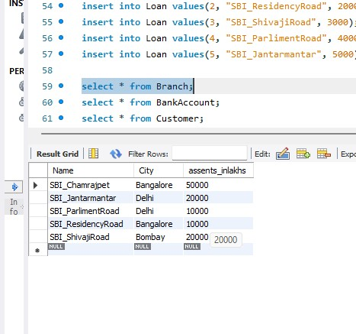

select * from BankAccount;

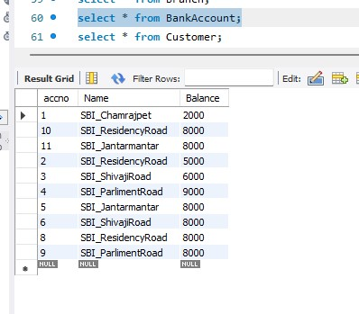

select * from Customer;

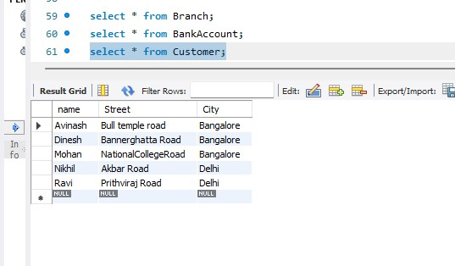

select * from Depositer;

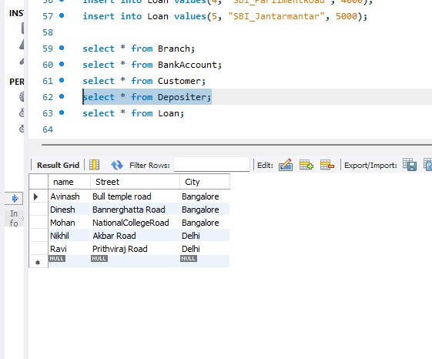

select * from Loan;

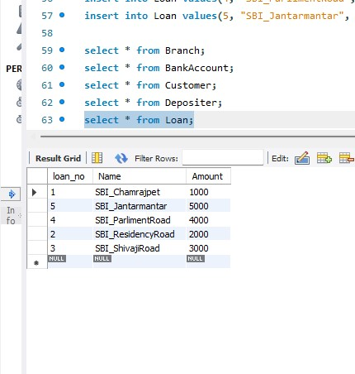

alter table branch

change assets assents_inlakhs real;

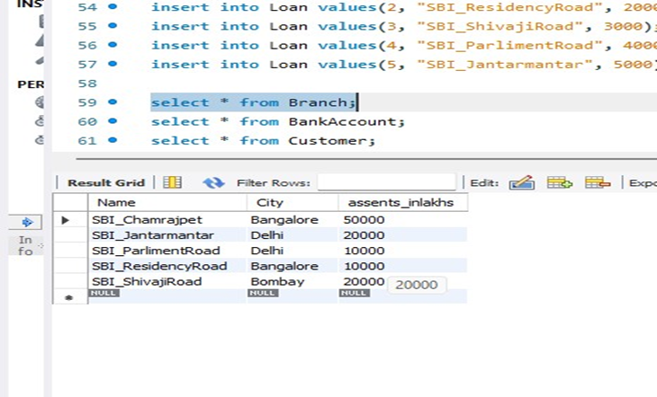

select d.Customername from Depositer d, BankAccount bank where

b.Branch_name='SBI_ResidencyRoad' and d.Accno=b.Accno group by d.Customername

having count(d.Accno)>=2;